**Graduate Aptitude Test in Engineering 2017**

**Question Paper Name:** Computer Science and Information Technology 11th Feb 2017 Session 1

**Subject Name: ** **Duration:** 180

**Total Marks:** 100



Question Number : 2 Correct : 1 Wrong : -0.33

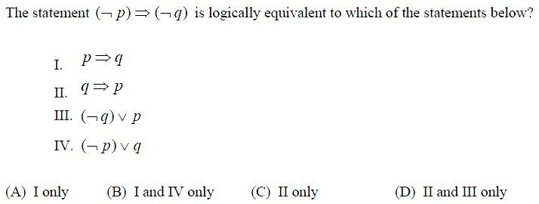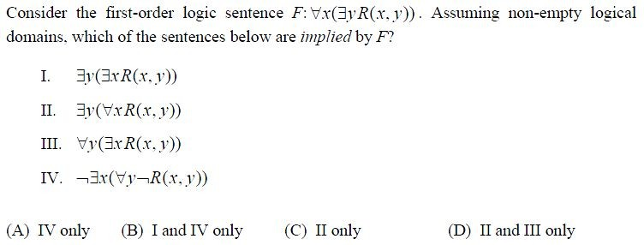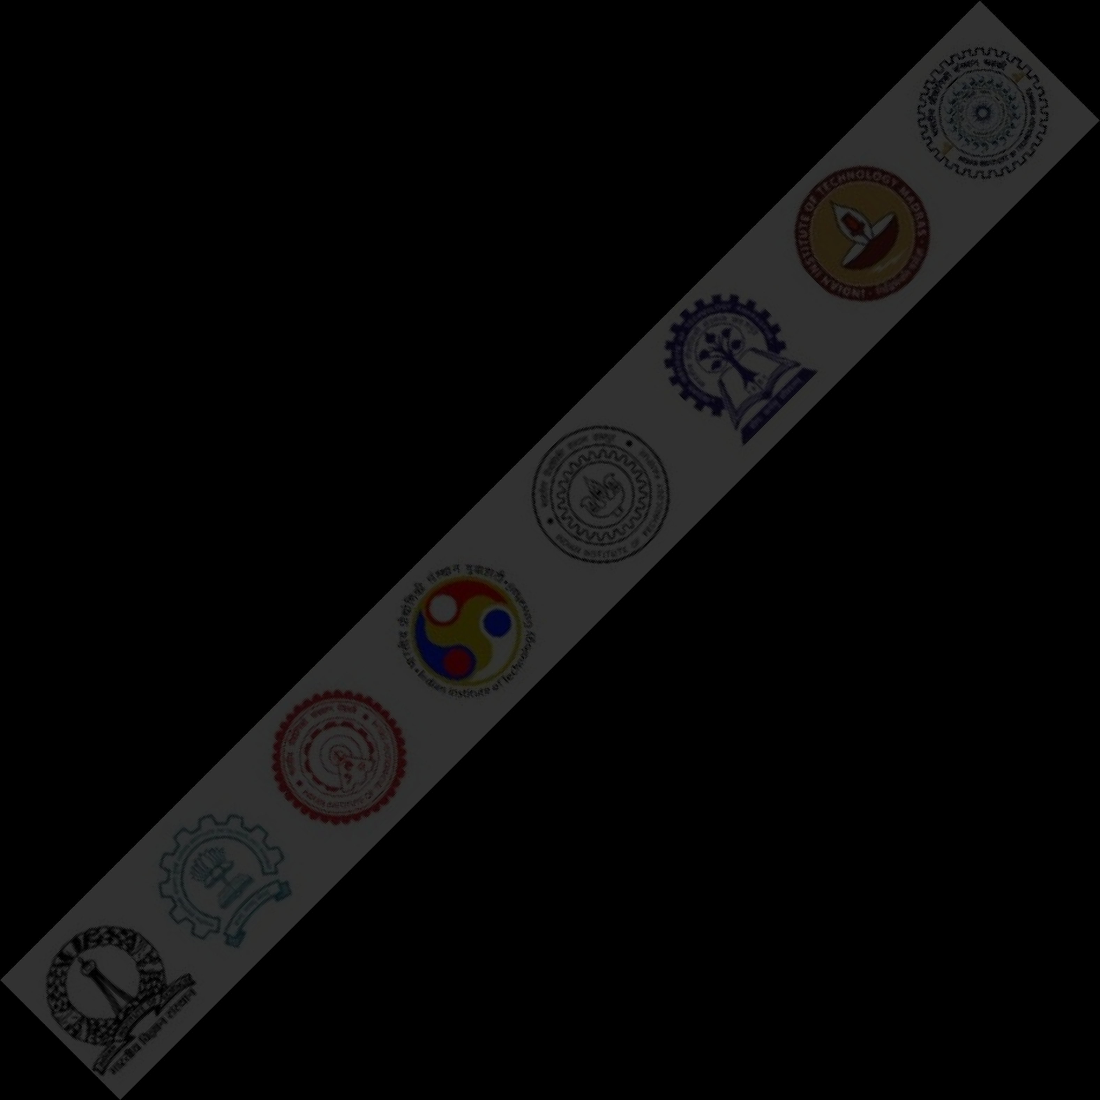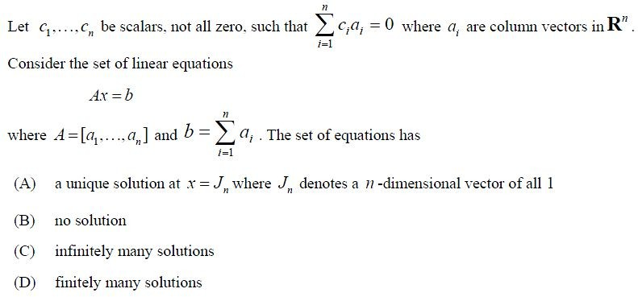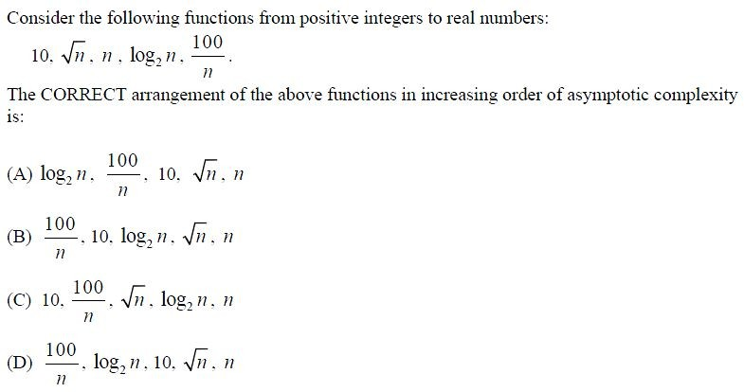

Question Number : 4 Correct : 1 Wrong : -0.33

Question Number : 6 Correct : 1 Wrong : -0.33

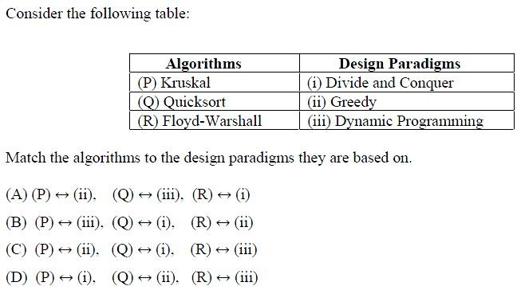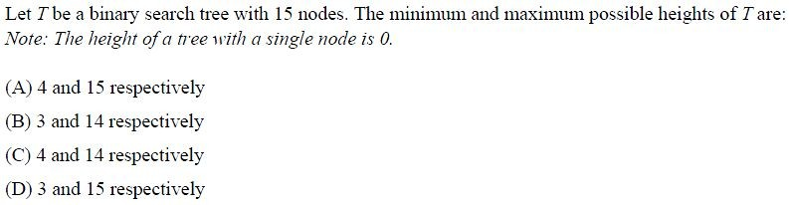

Question Number : 7 Correct : 1 Wrong : -0.33

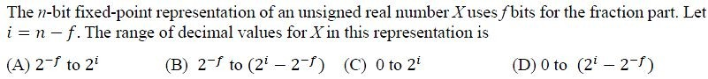

Question Number : 9 Correct : 1 Wrong : -0.33

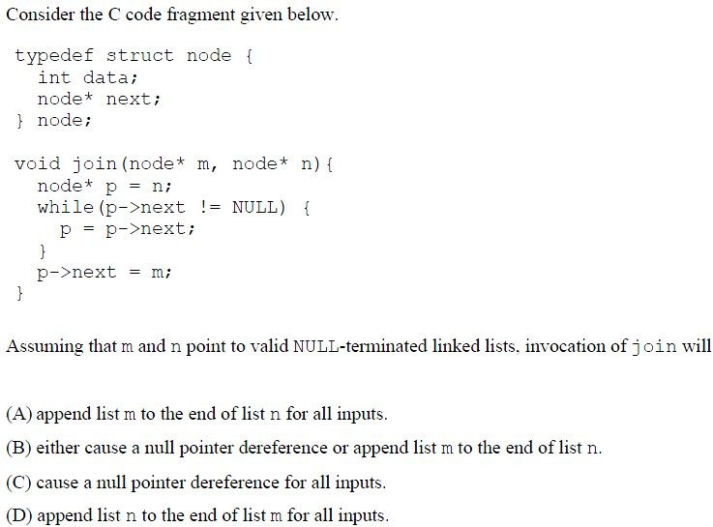

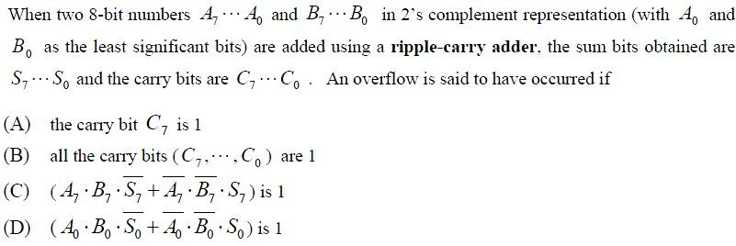

Question Number : 11 Correct : 1 Wrong : -0.33

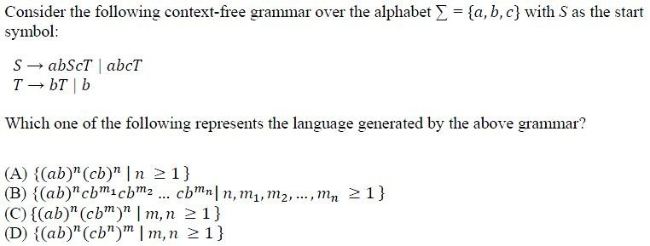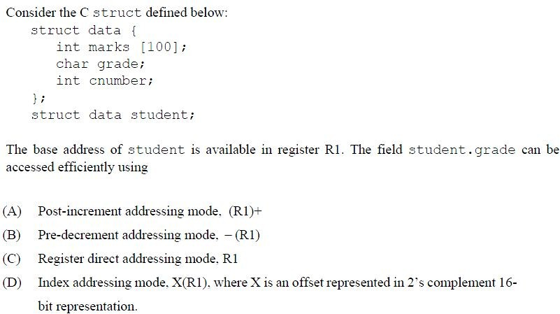

Question Number : 12 Correct : 1 Wrong : -0.33

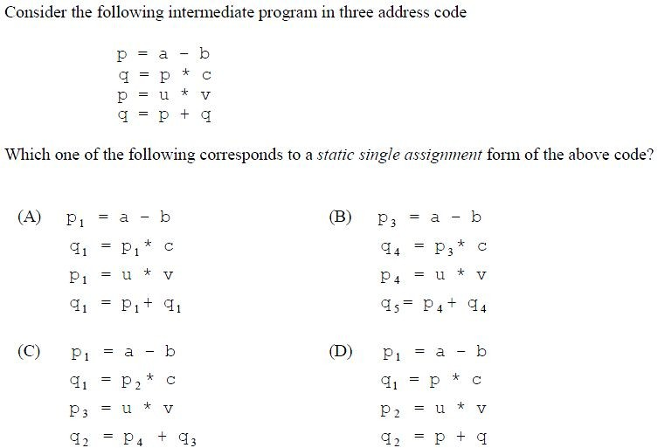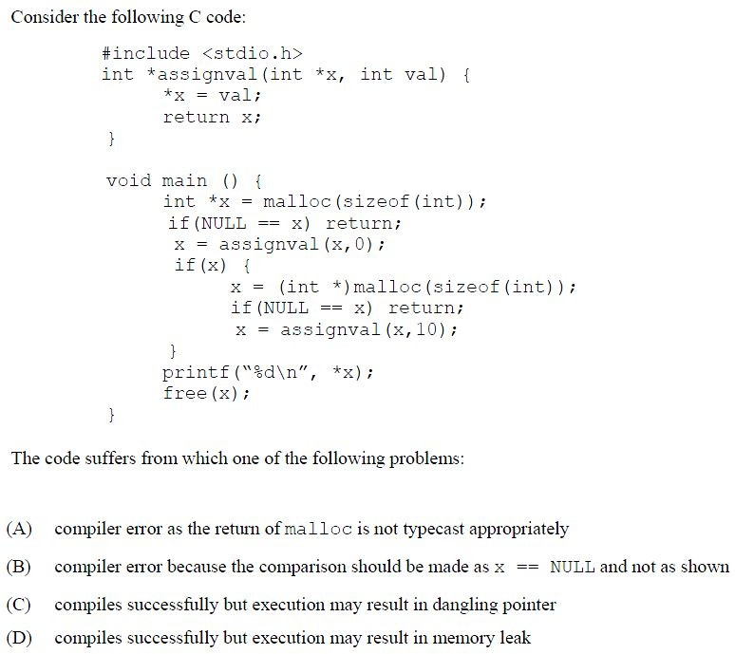

Question Number : 14 Correct : 1 Wrong : -0.33

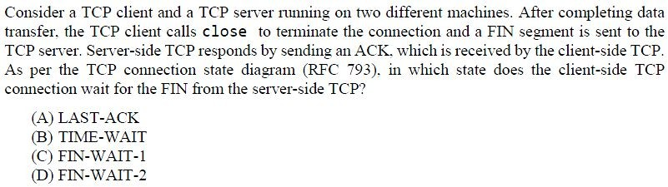

Question Number : 16 Correct : 1 Wrong : -0.33

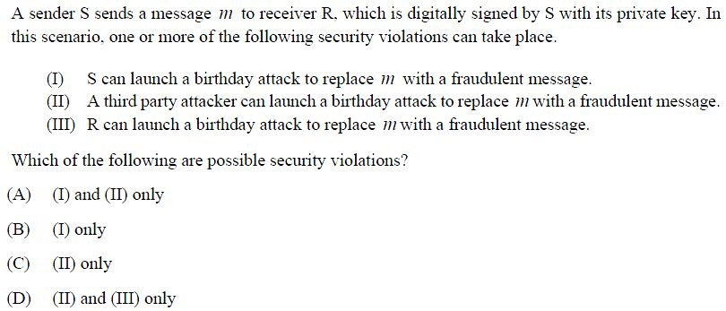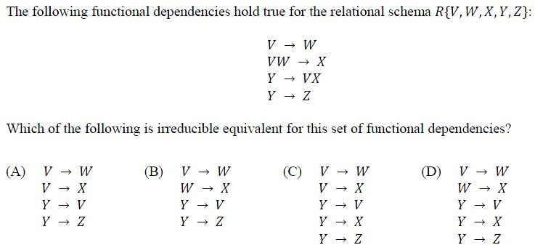

Question Number : 18 Correct : 1 Wrong : -0.33

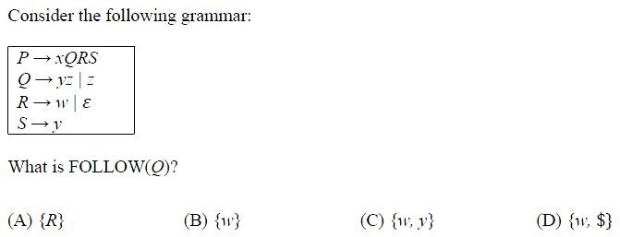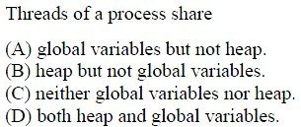

Question Number : 19 Correct : 1 Wrong : 0



Question Number : 20 Correct : 1 Wrong : 0



Question Number : 22 Correct : 1 Wrong : 0

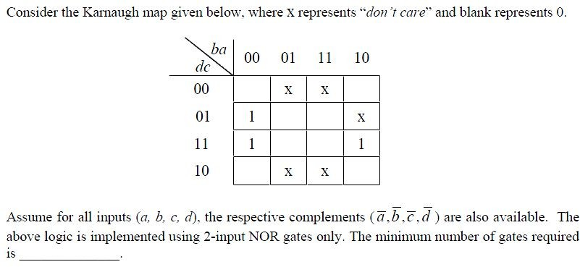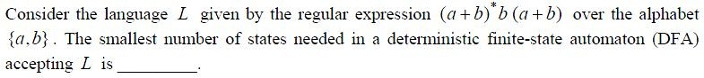

Question Number : 24 Correct : 1 Wrong : 0

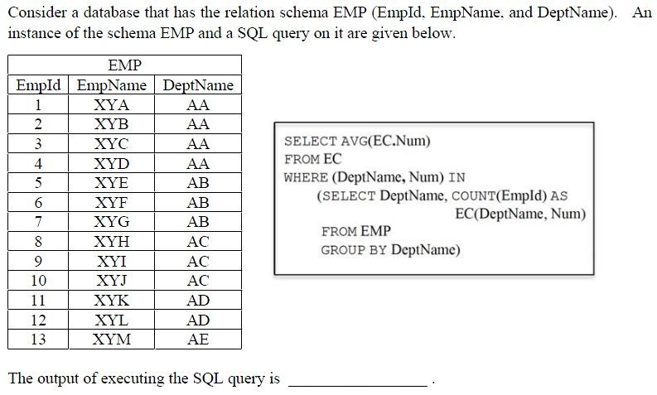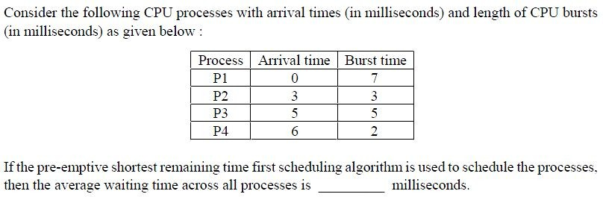

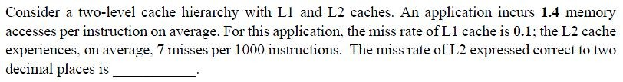

Question Number : 26 Correct : 2 Wrong : -0.66

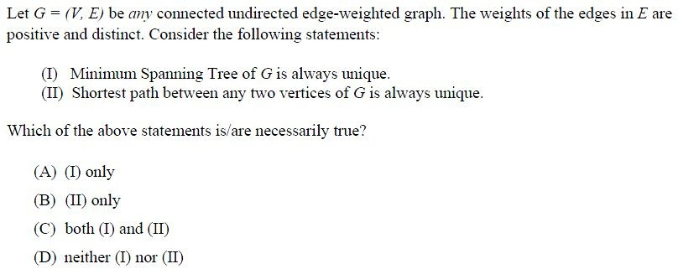

**Question Number : 27**

**Correct : 2 Wrong : -0.66**

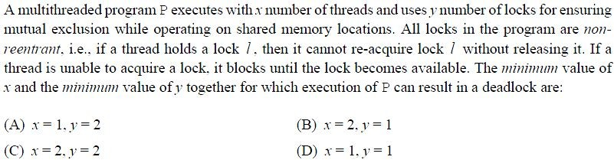

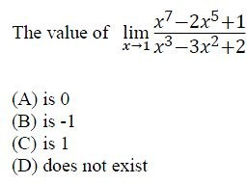

Question Number : 29 Correct : 2 Wrong : -0.66

Question Number : 30 Correct : 2 Wrong : -0.66

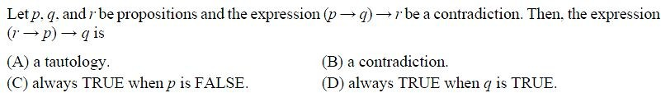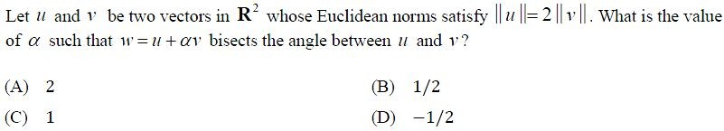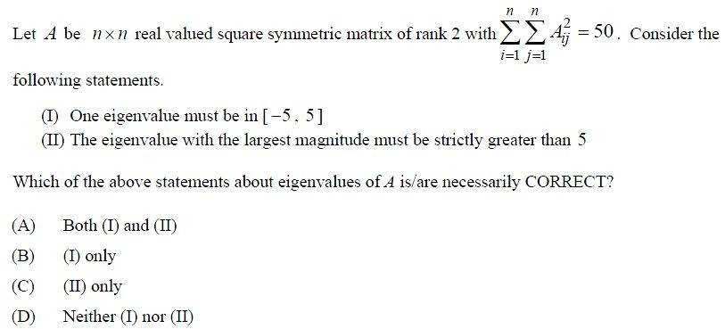

Question Number : 31 Correct : 2 Wrong : -0.66

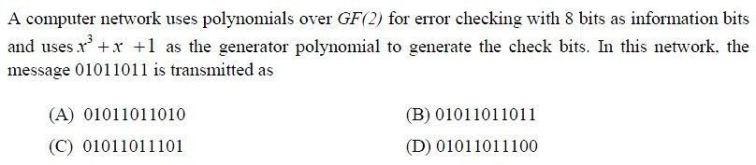

Question Number : 33 Correct : 2 Wrong : -0.66

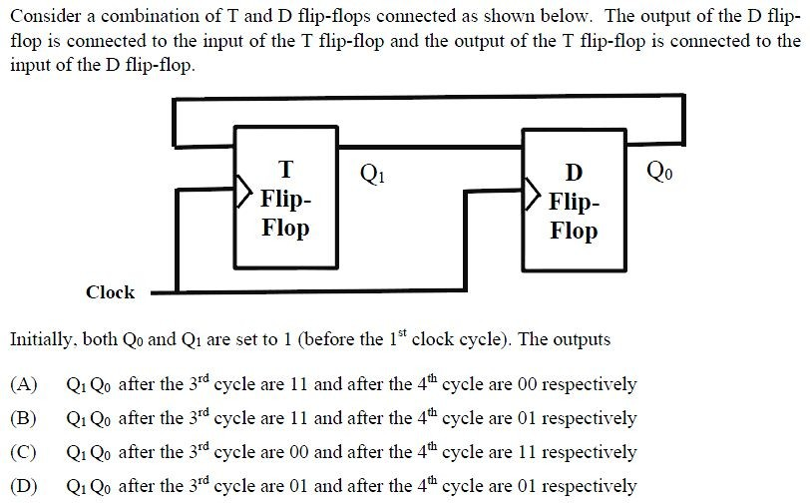

Question Number : 34 Correct : 2 Wrong : -0.66

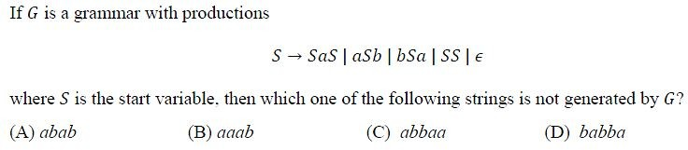

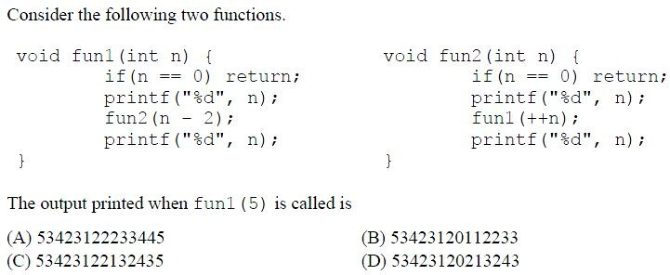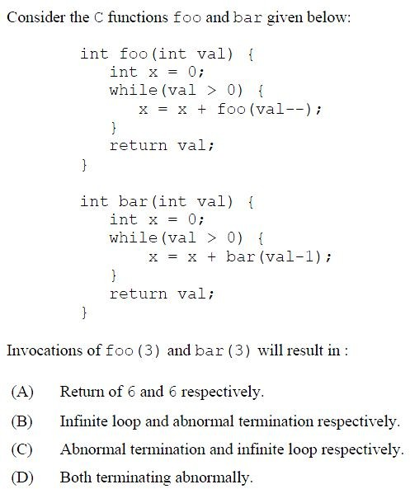

Question Number : 36 Correct : 2 Wrong : -0.66

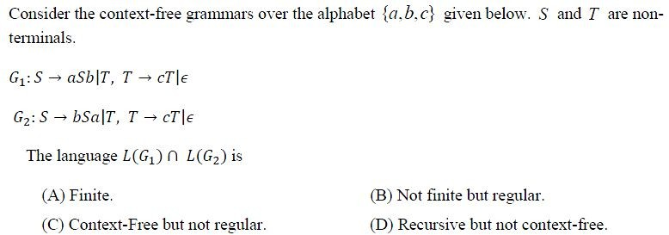

Question Number : 38 Correct : 2 Wrong : -0.66

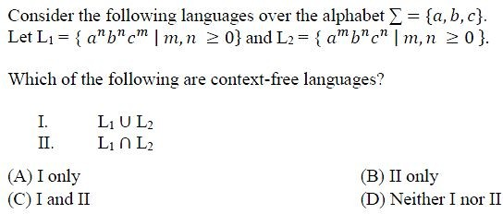

Question Number : 39 Correct : 2 Wrong : -0.66

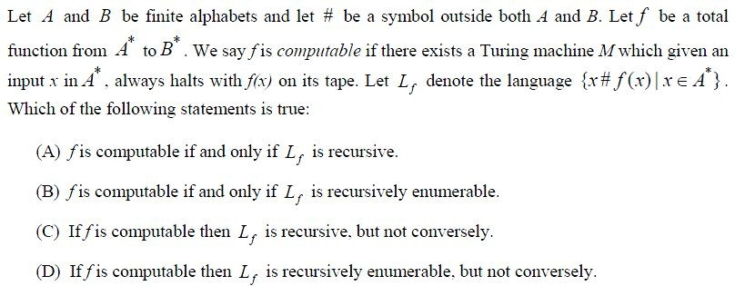

Question Number : 41 Correct : 2 Wrong : -0.66

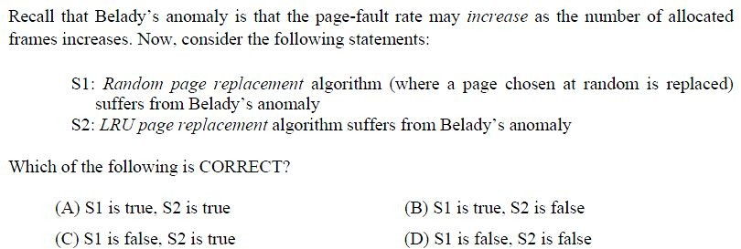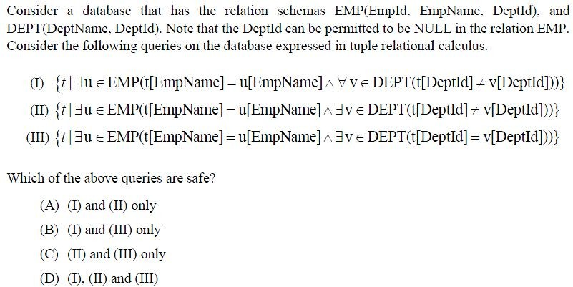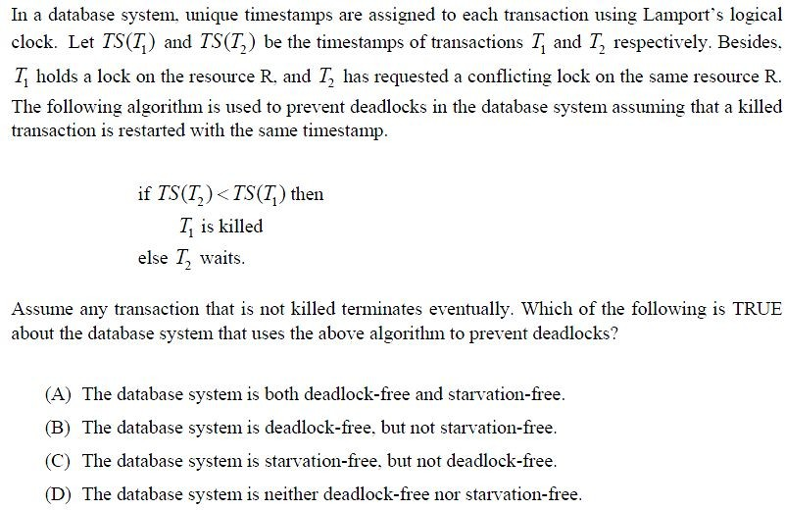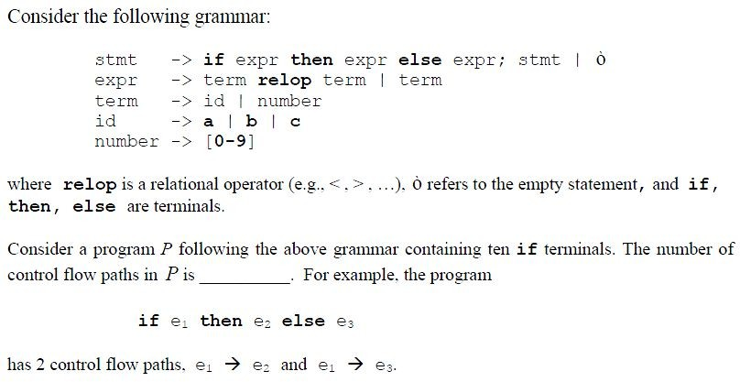

Question Number : 43 Correct : 2 Wrong : 0



Question Number : 45 Correct : 2 Wrong : 0

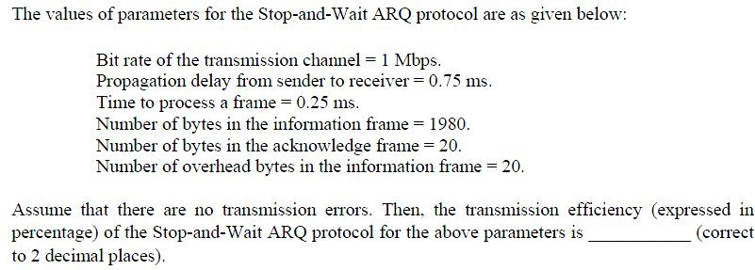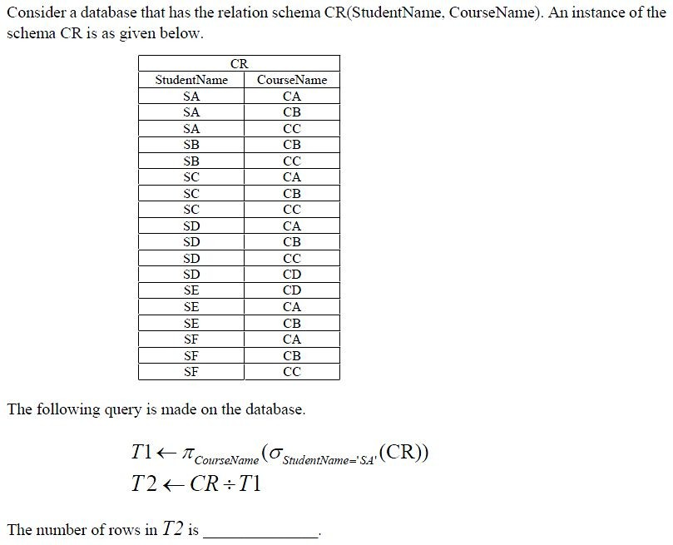

Question Number : 47 Correct : 2 Wrong : 0



Question Number : 48 Correct : 2 Wrong : 0

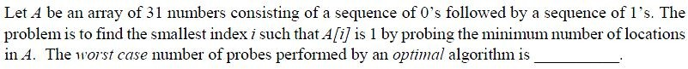

Question Number : 50 Correct : 2 Wrong : 0

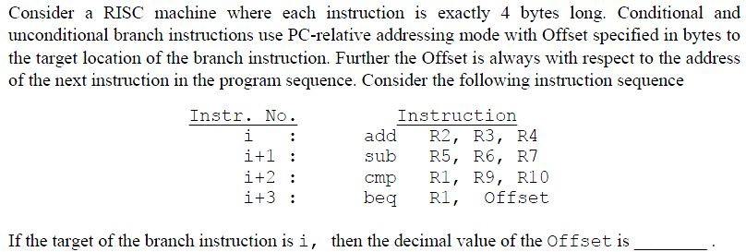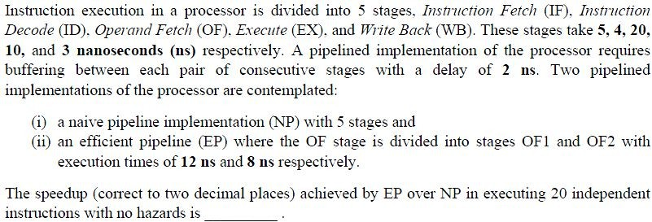

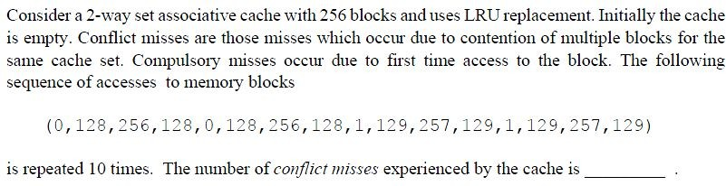

Question Number : 52 Correct : 2 Wrong : 0

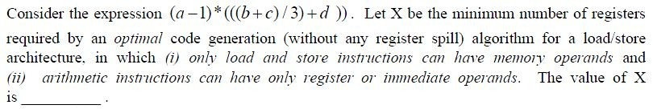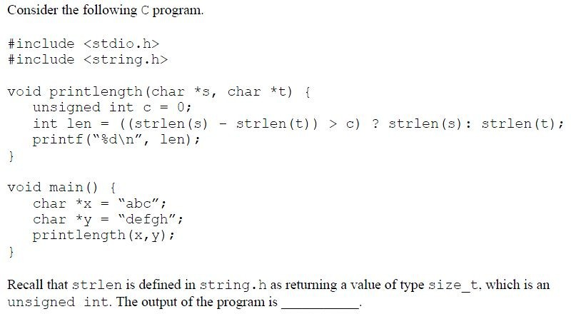

Question Number : 53 Correct : 2 Wrong : 0

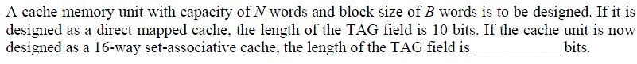

Question Number : 55 Correct : 2 Wrong : 0

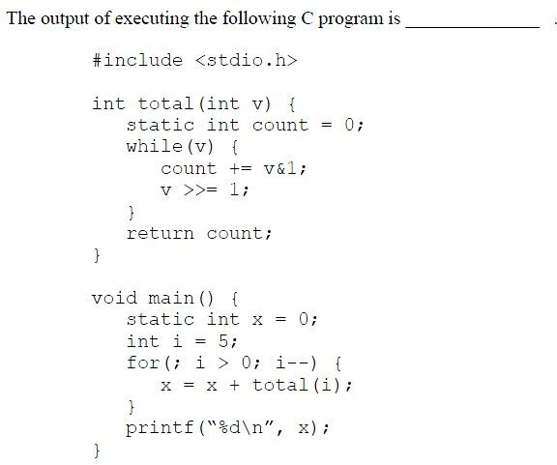

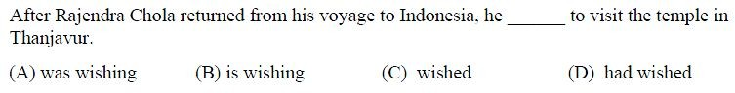

Question Number : 57 Correct : 1 Wrong : -0.33

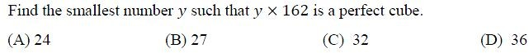

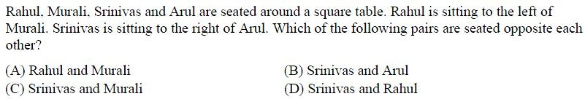

**Question Number : 58**

**Correct : 1 Wrong : -0.33**

**Question Number : 59**

**Correct : 1 Wrong : -0.33**

Question Number : 60 Correct : 1 Wrong : -0.33



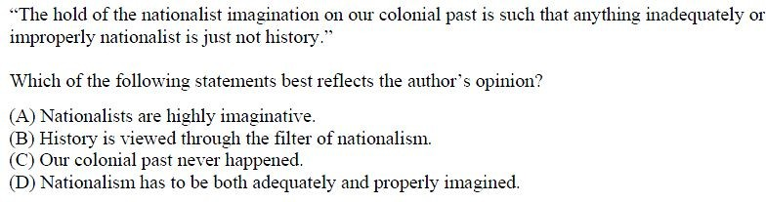

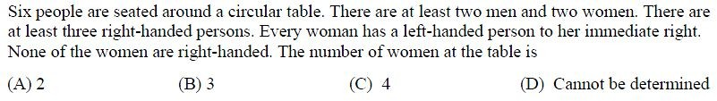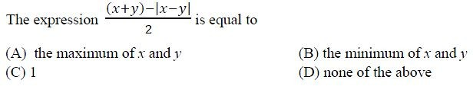

**Question Number : 62**

**Correct : 2 Wrong : -0.66**

**Question Number : 63**

**Correct : 2 Wrong : -0.66**

Question Number : 64 Correct : 2 Wrong : -0.66

